

**ANKARA YILDIRIM BEYAZIT UNIVERSITY**

**FACULTY OF ENGINEERING AND NATURAL SCIENCES**

Electrical & Electronics Engineering

**DIGITAL IMAGE PROCESSING (EE409)**

**TERM PROJECT – REPORT**

**Name – Surname Student No**

Murat SARIKAYA 18050211023

Salih Enes ŞEKER 18050211050

Asst. Prof. Dr. Gökhan Koray GÜLTEKİN

Cartoonize an Image

**CONTENTS**

**CONTENTS .2**

**CARTOONIZATION .3**

**MATLAB GUI .10**

**DEMO .12**

**REFERENCES 20**

**CARTOONIZATION**

The topic of the project is cartoonization. But, we did not learn this subject in lessons. So, firstly we need to searched in literature. In the literature, only a few cartoon functions are available and this functions are written in Python. In this project, we try to write MATLAB version of the Python codes. Our cartoon function consists of five part. For the project report, we use the ‘**pala.jpg**’ for show the every steps.

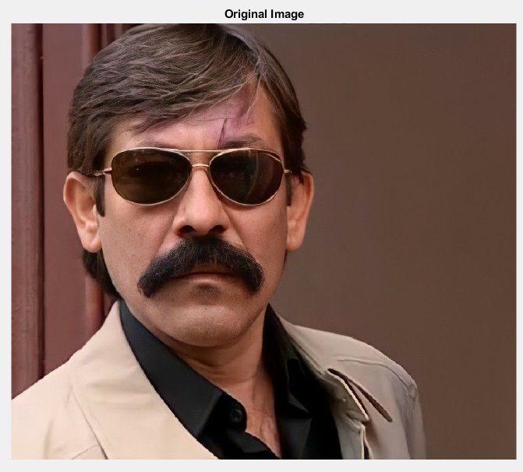

Figure 1

1. **Histogram Equalization**

In this part, our aim is try to balance pixel values. When we do not use histogram equalization, face of the people in image has so much white reflections. After the equalization, we reduce this white reflections and we get better result in cartoon image.

Before the histogram equalization, we used a 5x5 median filter on the original image to scan every color channel by using for loop. The reason for using the median filter is we must detect the edges and remove the thin lines. But, if we do not use median filter, the edges are more complicated, and we may see the residual lines or shapes in the final cartoon image and median filter gets better performance than average or min-max filter for detecting the edges. Using median filter makes the edges more suitable for this project. Also, we chose filter size as 5x5 due to the result of our trials.

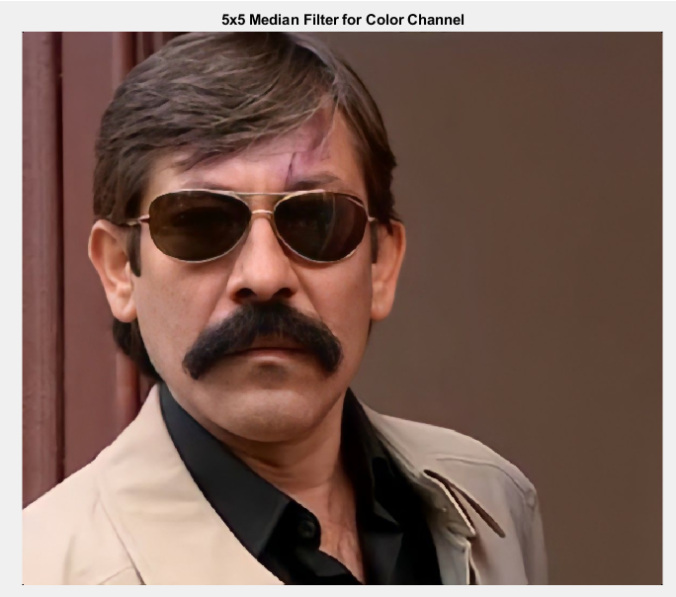

Figure 2

Then we apply histogram equalization. For the histogram equalization we need to ‘max_luminosity’ parameter to decide brightness. This parameter gets from user in GUI. In the our algorithm, for the without edges cartoonization, the ideal max_luminosity parameter is around the 70. For the with edges cartoon image, the ideal max_luminosity parameter is around 90. But, this values are not valid every image. Every image is special and has own best parameters. So, we can give the chance the users to them obtain the best cartoonization image.

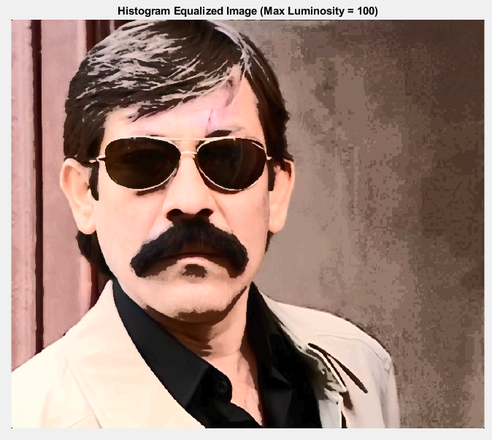

Figure 3

1. **Edge Detection**

For the cartoon image with edges, we need to detect edges. We use ‘edge’ function and ‘sobel’ operator in both directions (horizontal and vertical).

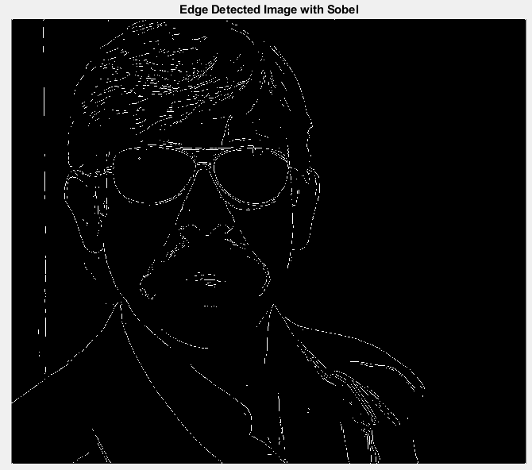

Figure 4

Then we use ‘imdilate’ function to change the thickness of the edges. We chose 1x1 rectangle shape structure element. Lastly we get complement of the image.

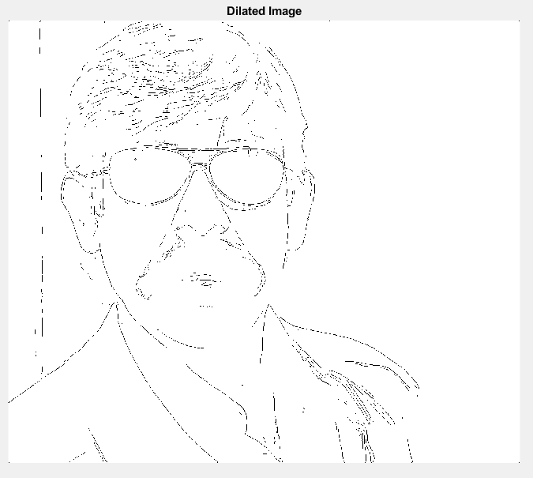

Figure 5

1. **Bilateral Filter**

In the cartoonization, the most important part is the bilateral filter. Since we did not learn in lesson, we research this filter on internet. A bilateral filter is a non-linear, edge-preserving, and noise-reducing smoothing filter for images. It replaces the intensity of each pixel with a weighted average of intensity values from nearby pixels. This weight can be based on a Gaussian distribution. Actually, MATLAB has a ‘imbilatfilt’ function but we can not get good results with this function. So, we found a bilateral filter code from the MathWorks. This bilateral filter code consist of 2 function (bfilter2 and colorspace) and more than 500 lines code. We try to understand the parameters and we edit the code much as possible. Firstly, we add a random noise to the image. Then, we decide the our parameters (half width(w) and standart deviation (sigma)).

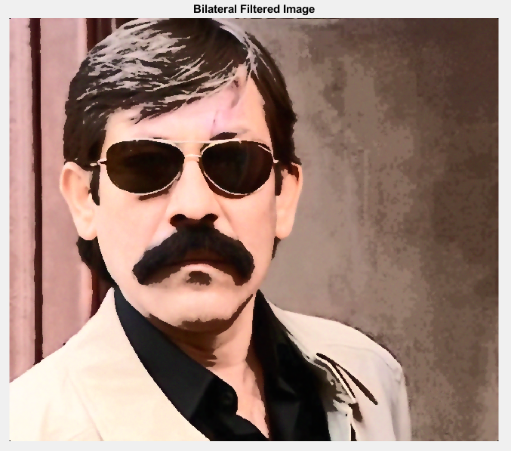

Figure 6

1. **Color Quantization**

After this step, we quantize the image by using the ‘multithresh’ and ’imquantize’ functions. Multithresh function helps us to reduce the color palette of the images. So, we can choose, for example, 10 colors instead of 50 and we may get more cartoon images. Also, we change the cartoon level of the images by changing this threshold value. This threshold value can changeble by users from GUI. When we increase the threshold, we get more color variants and the image looks real but if we decrease it, it shows as cartoon image. Then we use 5x5 median filter to reduce the noise after quantization process. For the figure 7, the threshold value is 6. This value is minimum threshold value(maximum cartoon level).

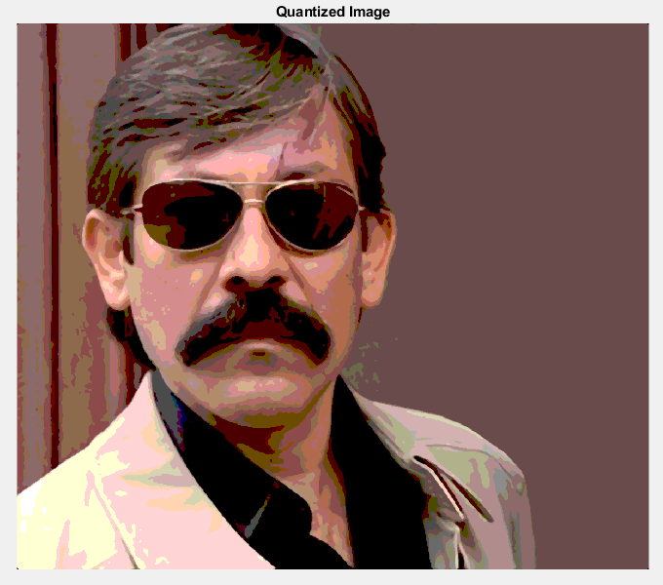

Figure 7

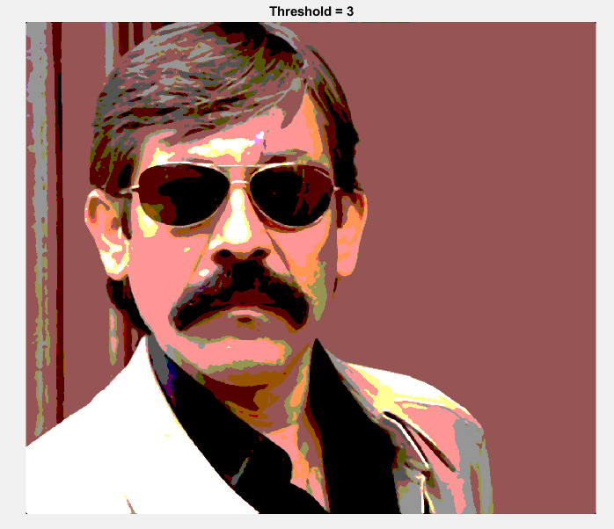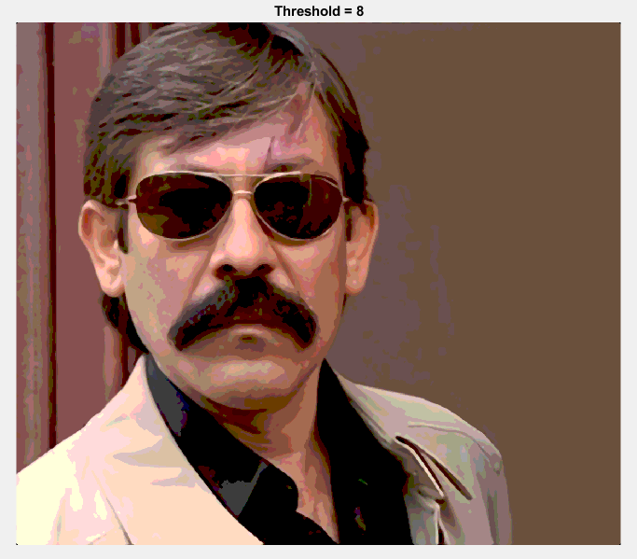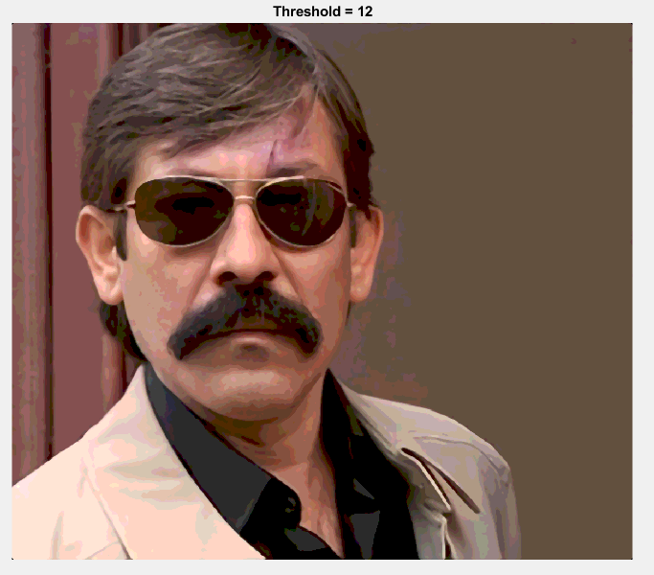

Figure 8

Threshold values are 3, 8 and 12 respectively in figure 8.

1. **Recombine (Sharpening)**

In the last step, for the without edges cartoonization, we use ‘imsharpen’ function to get more sharpened image. And for the cartoonization with edges, we use ‘imfuse’ function to combine two images (quantized image and dilated image). We use ‘blend’ method for fusing the image. Blend overlays the first image and second image using alpha blending.

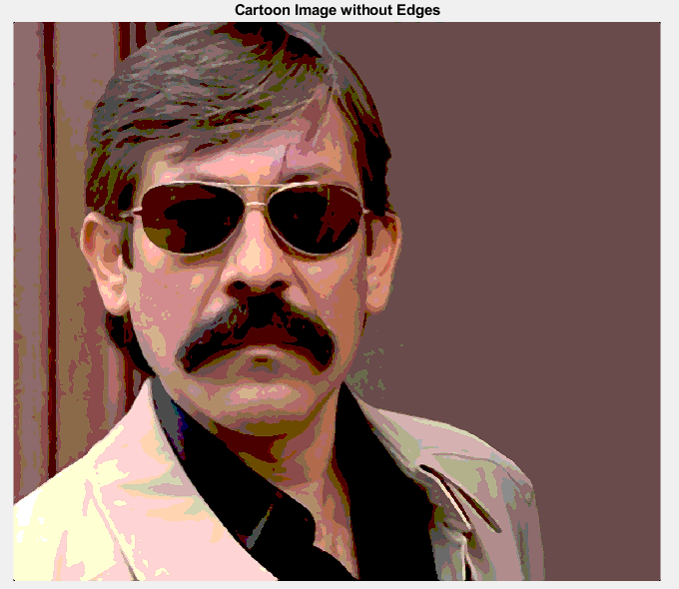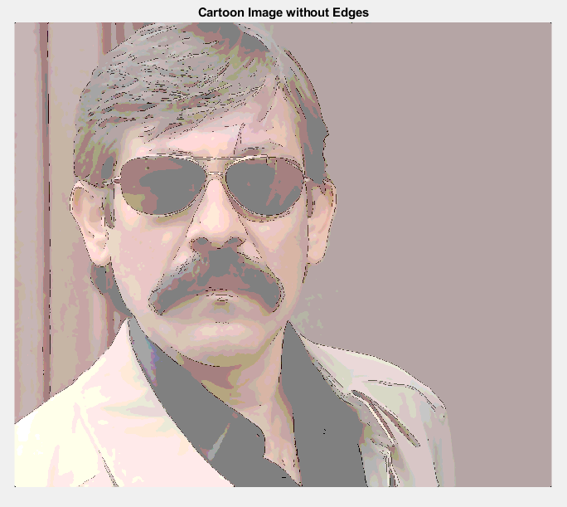

Figure 9

End of the code, we can get two different cartoon images. The cartoon image without edges obtain the good results except portrait images. And cartoon image with edges obtain the good results especially in portrait images.

**MATLAB GUI**

When we finish the cartoonize function, we design our Graphical User Interface (GUI) in MATLAB. For the GUI, we use the ‘GUIDE’.

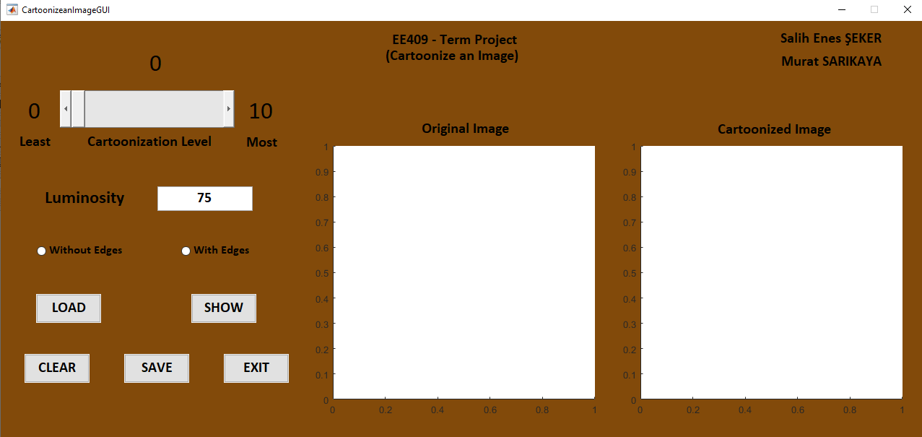

Figure 10

When we start of our GUI, we can see this interface like Figure 10. GUI contains one slider, one edit text, two radio buttons, five push buttons, two axes and some static texts. From the slider, user can adjust the cartoonization level between 0 and 10. When cartoonization level is 0, do not applied any cartoonization functions to the image. If users increase the cartoonization level, they get more cartoonized image until the 10. This max value is submit the most cartoonized image for users. On the Luminosity edit text, users can enter the luminosity for the image. It ensure the get more eye-pleasing cartoon image. Then, we tender users two choice for the cartoonization. If users don’t have portrait images and they would eye-pleasing image, we recommended the select the without edge. If users have portrait images, we advise the select cartoonization with edges radio button. Thereafter, users need to use push buttons work on the GUI. Users should upload their images which they want to cartoonize from their computer to the GUI with the 'LOAD' button. Then, if users determine the parameters, they should press ‘SHOW’ button to see the cartoonized image. Users show their original image and cartoonize image in the labeled two axes. Then, we have three optional buttons. ‘CLEAR’ button is clear the two axes. ‘SAVE’ button is ensure the save cartoonized image to the computer. Lastly, with the press the ‘EXIT’ button GUI will close.

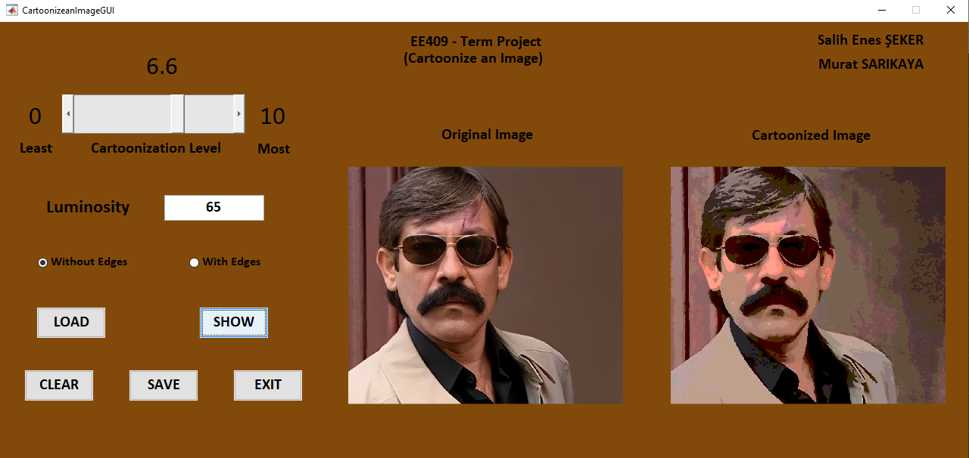

Figure 11

**DEMO**

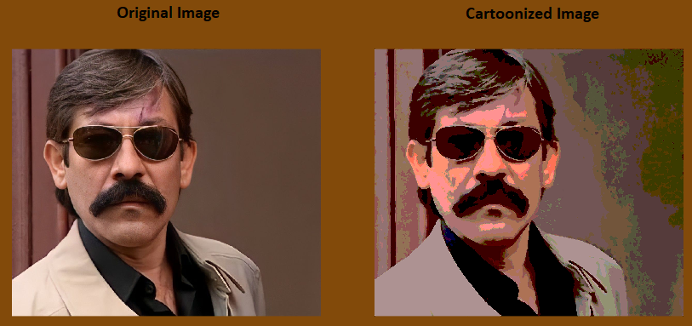

Figure 12

(Cartoonization Level = 10, Luminosity = 60, Without Edges)

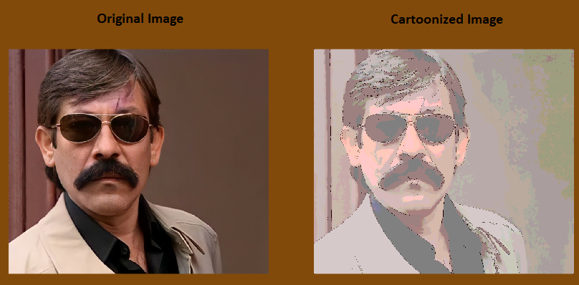

Figure 13

(Cartoonization Level = 10, Luminosity = 60, With Edges)

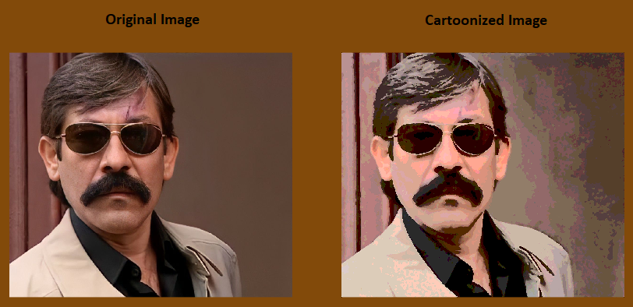

Figure 14

(Cartoonization Level = 5, Luminosity = 80, Without Edges)

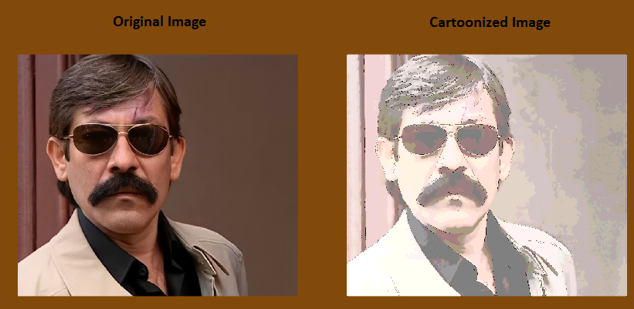

Figure 15

(Cartoonization Level = 8, Luminosity = 100, With Edges)

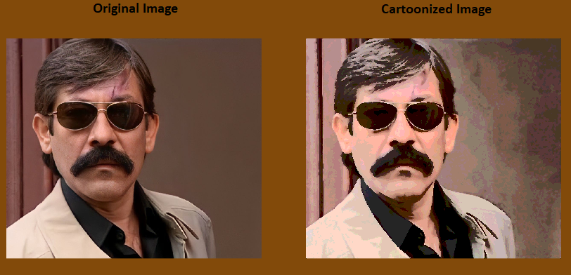

Figure 16

(Cartoonization Level = 3, Luminosity = 85, Without Edges)

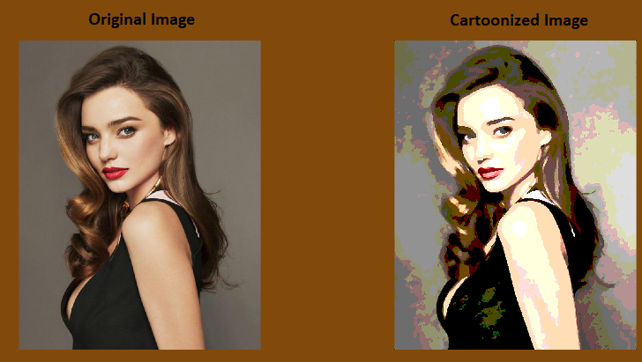

Figure 17

(Cartoonization Level = 10, Luminosity = 100, Without Edges)

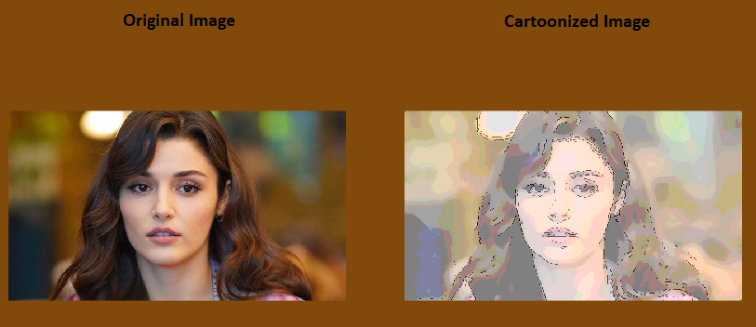

Figure 18

(Cartoonization Level = 10, Luminosity = 80, With Edges)

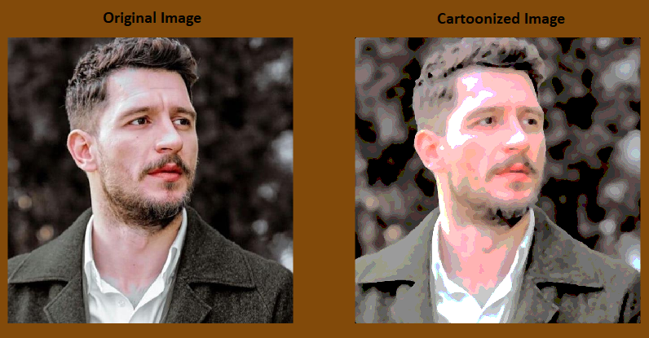

Figure 19

(Cartoonization Level = 7, Luminosity = 85, Without Edges)

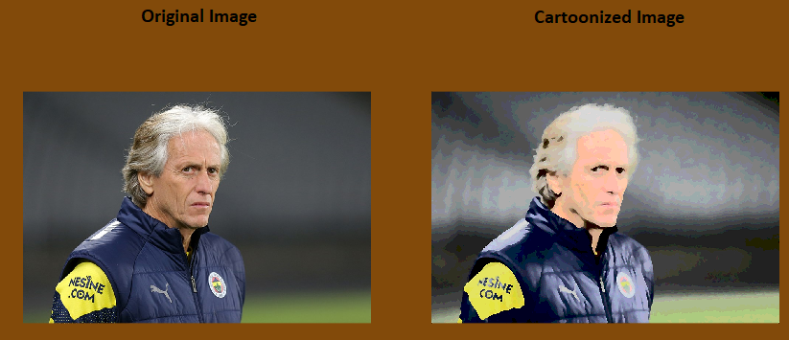

Figure 20

(Cartoonization Level = 1, Luminosity = 85, Without Edges)

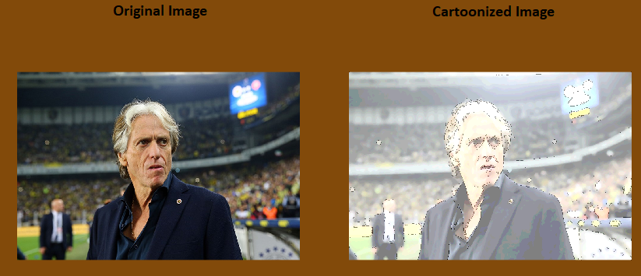

Figure 21

(Cartoonization Level = 4, Luminosity = 105, With Edges)

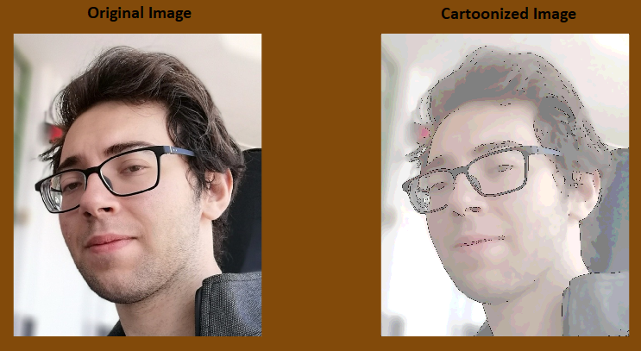

Figure 22

(Cartoonization Level = 6, Luminosity = 100, With Edges)

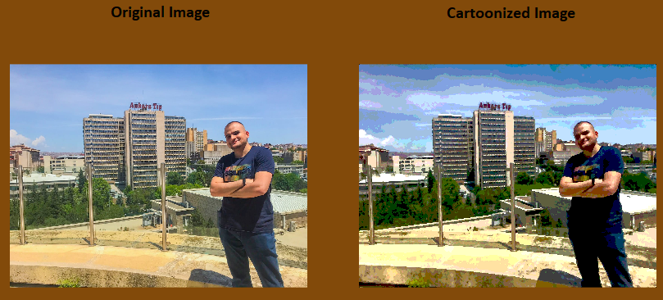

Figure 23

(Cartoonization Level = 9, Luminosity = 100, Without Edges)

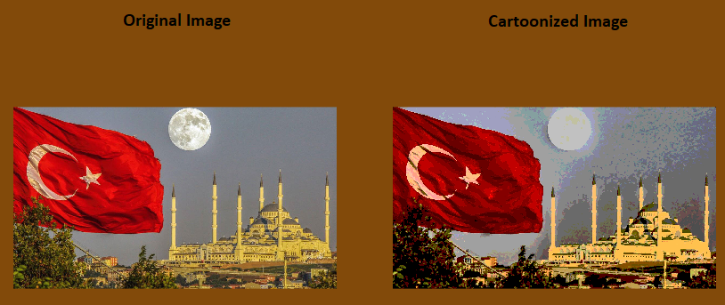

Figure 24

(Cartoonization Level = 10, Luminosity = 75, Without Edges)

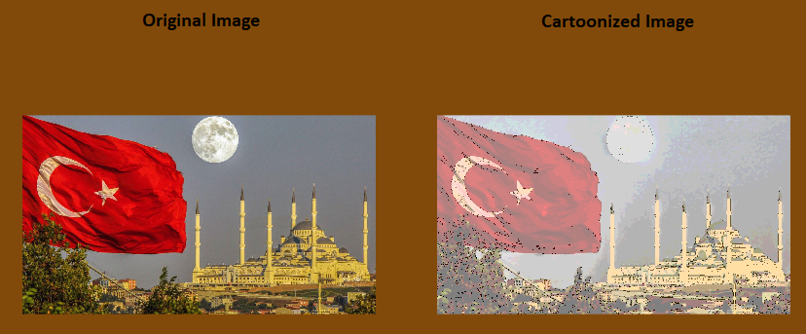

Figure 25

(Cartoonization Level = 10, Luminosity = 75, With Edges)

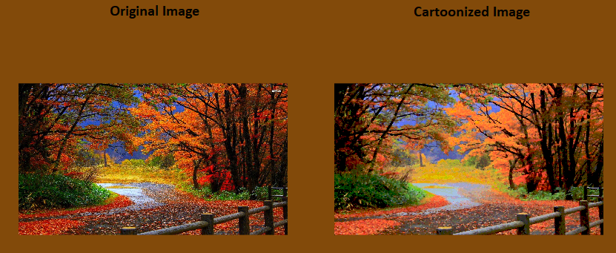

Figure 26

(Cartoonization Level = 7, Luminosity = 70, Without Edges)

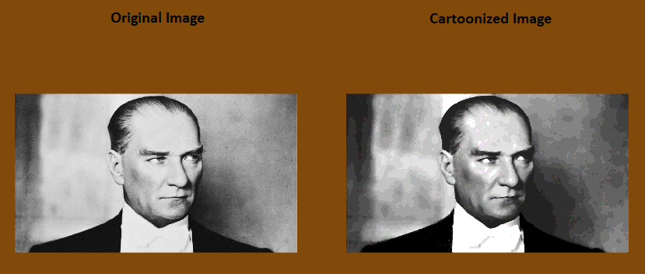

Figure 27

(Cartoonization Level = 2, Luminosity = 95, Without Edges)

**REFERENCES**

1. <https://www.youtube.com/watch?v=2xqvGZS7NCw&ab_channel=edureka%21>
2. <https://www.mathworks.com/matlabcentral/fileexchange/12191-bilateral-filtering?s_tid=srchtitle_cartoon_9>
3. <https://www.mathworks.com/help/images/ref/imquantize.html>
4. <https://www.youtube.com/watch?v=Y52XnpxqT0o&ab_channel=PratikJain>
5. <https://www.youtube.com/watch?v=BhUmatwM6BY&ab_channel=bycloudump>
6. <https://www.mathworks.com/help/images/ref/imsharpen.html>
7. <https://www.mathworks.com/help/images/ref/imbilatfilt.html>
8. <https://www.mathworks.com/help/images/contrast-enhancement-techniques.html>
9. <https://www.mathworks.com/help/images/ref/medfilt2.html?searchHighlight=medfilt2&s_tid=srchtitle_medfilt2_1>
10. <https://www.mathworks.com/help/images/edge-detection.html?searchHighlight=edge&s_tid=srchtitle_edge_4>
11. <https://www.mathworks.com/help/images/ref/imfuse.html?searchHighlight=imfuse&s_tid=srchtitle_imfuse_1>